Desktop_Workplace Project:
7/4/2012

C:\Grant - Dev - Trinity III - Controls 2\Desktop Workplace

Button Bar:

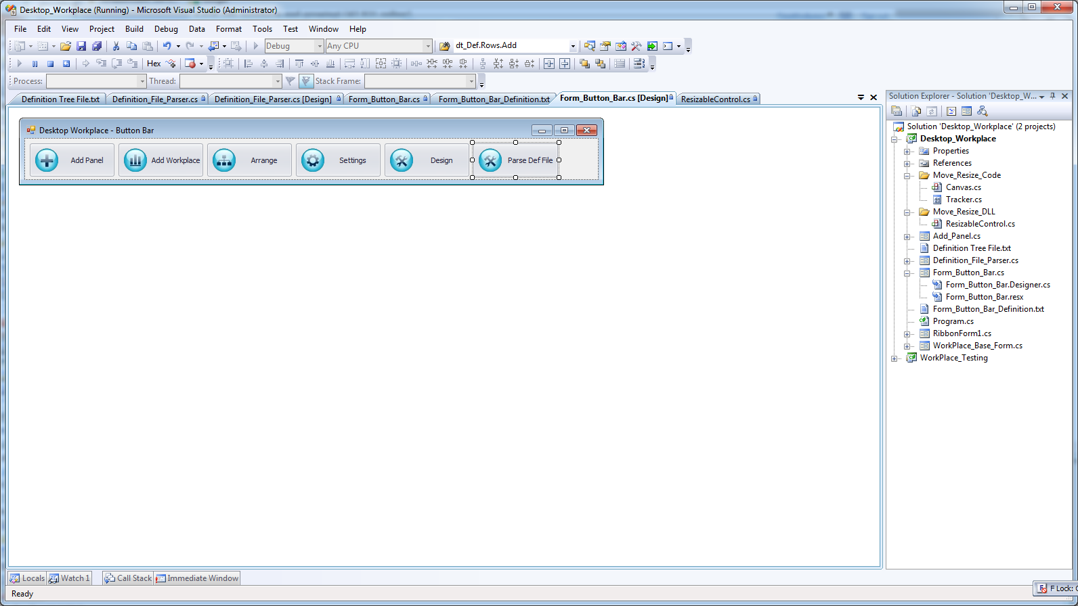

Definition File Parser:

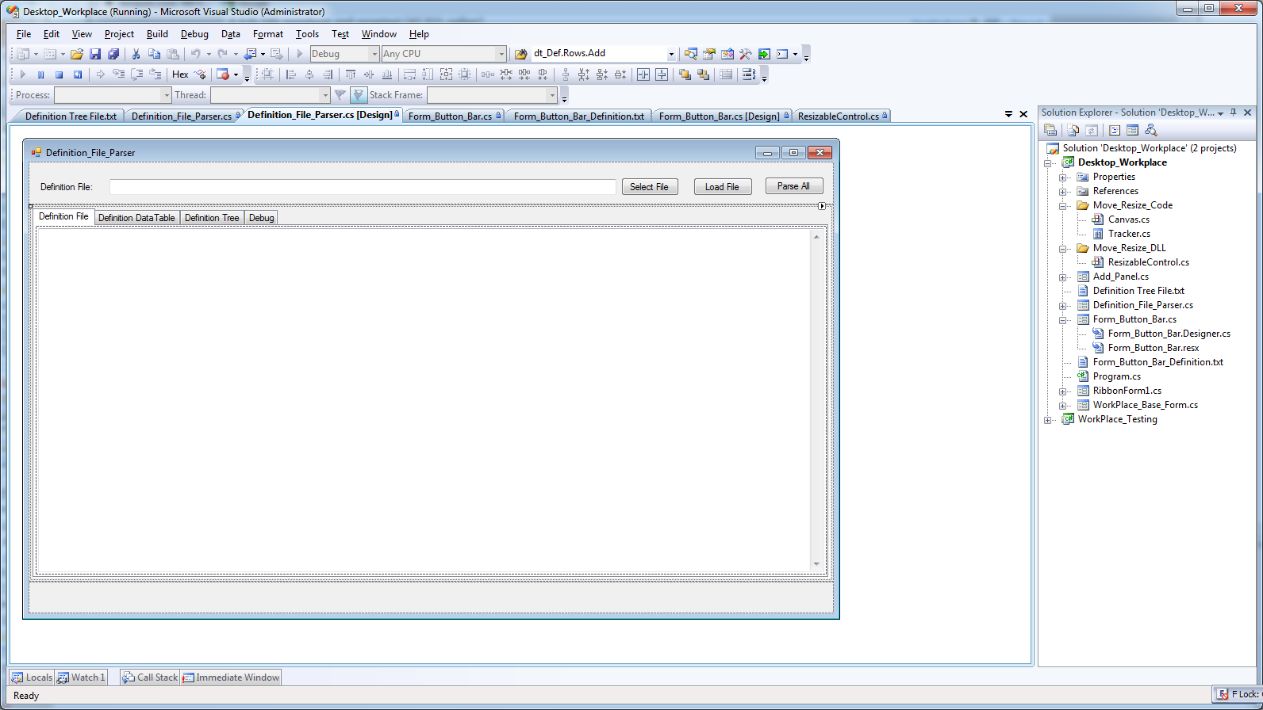

Definition Tree:

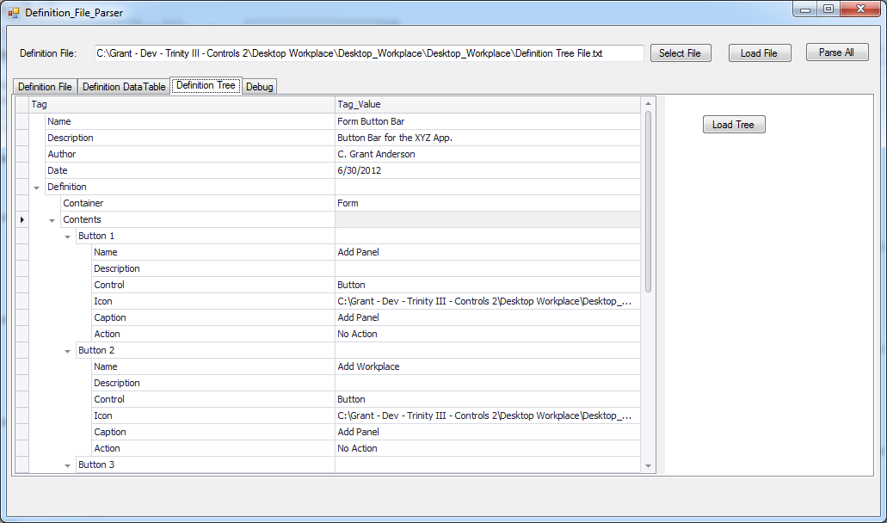

Definition Tree File:

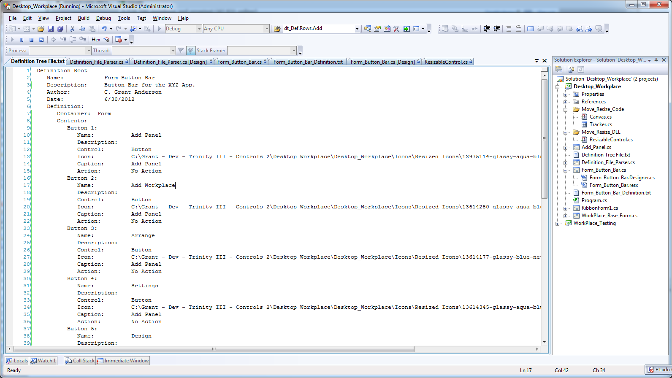

Definition Data Table:



